# hbase 1.2.1 分布式安装

## 1.机器信息

五台centos 64位机器

## 2.集群规划

|  |  |  |  |  |
| --- | --- | --- | --- | --- |
| **Server Name** | **Hadoop Cluster** | **Zookeeper Ensemble** | **HBase Cluster** | **Ip** |
| **Hadoop01** | Name node & Resource manager |  | Master | 192.168.12.60 |
| **Hadoop02** | Secondary name node |  |  | 192.168.12.61 |
| **Hadoop03** | Data node & Node manager | √ | Region server | 192.168.12.62 |
| **Hadoop04** | Data node & Node manager | √ | Region server | 192.168.12.63 |
| **Hadoop05** | Data node & Node manager | √ | Region server | 192.168.12.64 |

## 3 hbase安装

### 3.1查看版本支持

官网查看hadoop支持对应的hbase 版本

网址 http://hbase.apache.org/book.html

*Hadoop version support matrix*

* "S" = supported
* "X" = not supported
* "NT" = Not tested

|  | **HBase-0.94.x** | **HBase-0.98.x (Support for Hadoop 1.1+ is deprecated.)** | **HBase-1.0.x (Hadoop 1.x is NOT supported)** | **HBase-1.1.x** | **HBase-1.2.x** |
| --- | --- | --- | --- | --- | --- |
| Hadoop-1.0.x | X | X | X | X | X |
| Hadoop-1.1.x | S | NT | X | X | X |
| Hadoop-0.23.x | S | X | X | X | X |
| Hadoop-2.0.x-alpha | NT | X | X | X | X |
| Hadoop-2.1.0-beta | NT | X | X | X | X |
| Hadoop-2.2.0 | NT | S | NT | NT | X |
| Hadoop-2.3.x | NT | S | NT | NT | X |
| Hadoop-2.4.x | NT | S | S | S | S |
| Hadoop-2.5.x | NT | S | S | S | S |
| Hadoop-2.6.0 | X | X | X | X | X |
| Hadoop-2.6.1+ | NT | NT | NT | NT | S |
| Hadoop-2.7.0 | X | X | X | X | X |
| Hadoop-2.7.1+ | NT | NT | NT | NT | S |

说明支持2.7.2 支持1.2.x 所以接下来我就进行安装

### 3.2上传文件



### 3.3 解压文件

tar –zxvf hbase-1.2.1-bin.tar.gz –C /usr/app

### 3.4修改配置文件

#### 3.4.1 将hadoop 下hdfs-site.xml 和core-site.xml 拷贝到 hbase 下的conf 文件

#### 3.4.2 hbase-env.sh





使用外部zookeeper

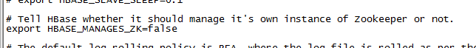

#### 3.4.3 hbase-site.xml

vim hbase-site.xml

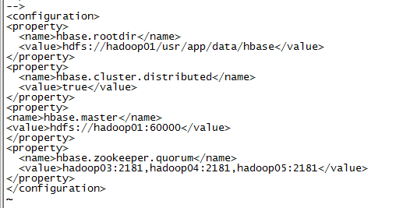

#### 3.4.4 regionservers

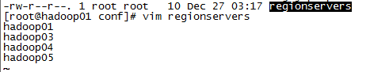

#### 3.4.5 环境变量

vim /etc/profile



## 4启动

